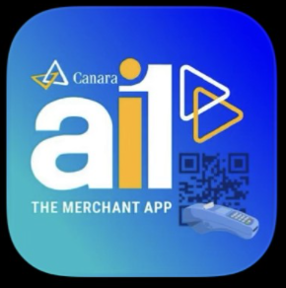

Link/QR code for the Canara ai1 Merchant Application is given below:

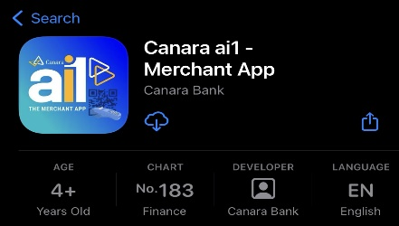

iOS:https://apps.apple.com/in/app/canara-ai1-merchant-app/id6444886142

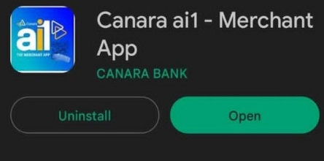

Android:https://play.google.com/store/apps/details?id=com.canarabank.candimerchant

Registration:

On-boarded Merchants can register themselves by following the below given
procedure when they download and open the App for the first time:

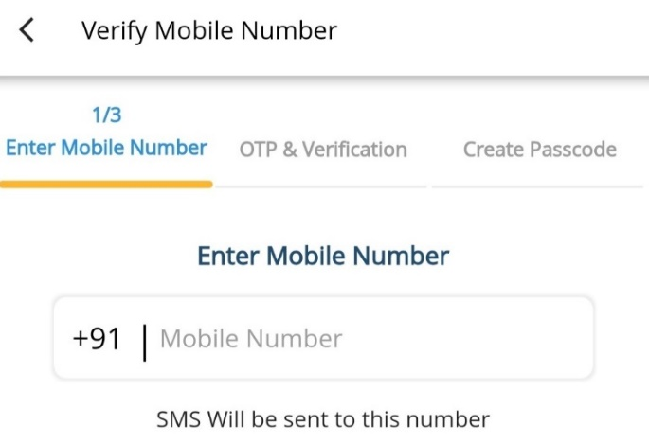
- Registered Mobile Number
Merchant can login with the mobile number used while on boarding him/her on the BHIM QR Merchant portal
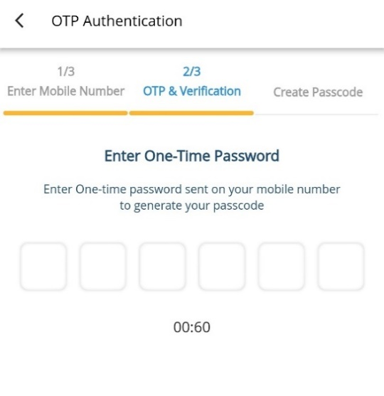

2. OTP for Mobile Number Verification

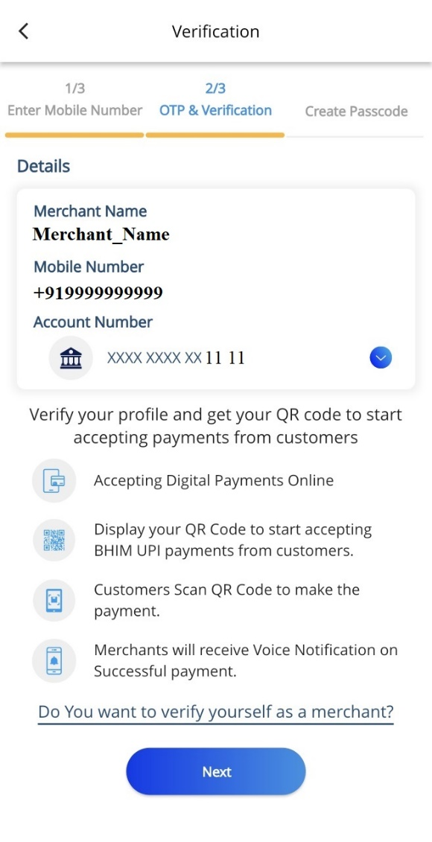

3. Merchant details page with Name, Mobile number, account number with the self- verification of being a Merchant

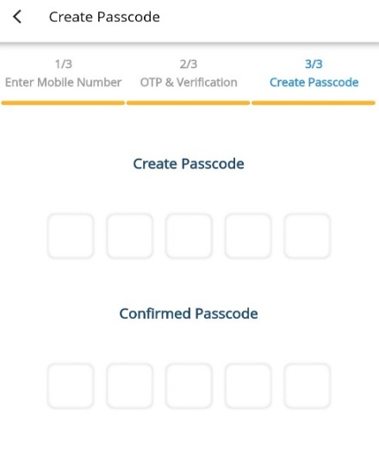

4. Create 5 Digit Passcode for Login

Registration is one-time activity; post which “Login Screen” will be the first page for the Merchants when they open the application.

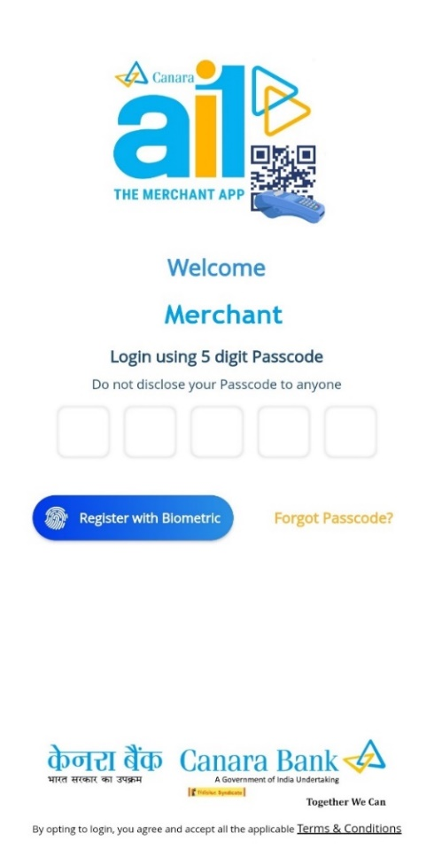
Login Screen
1. Passcode:
Merchant can login by using the passcode created at the time of Registration.

2. Register with biometric:
Merchant can also set the Biometric credentials of his/her smartphone as the passcode of the application.

3. “Forgot Passcode?”
Option to reset the password.

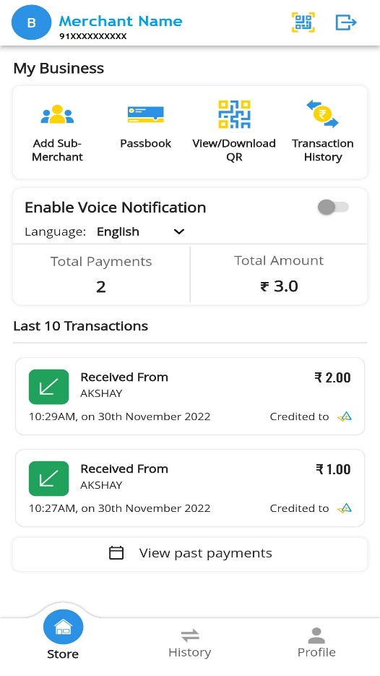
Home Screen

- Add Sub merchant
- Passbook with Summarized QR statement
- View/Download QR code
- Transaction History
- Enable Voice Notification
(in 9 regional languages)
- Today’s Last 10 Transactions

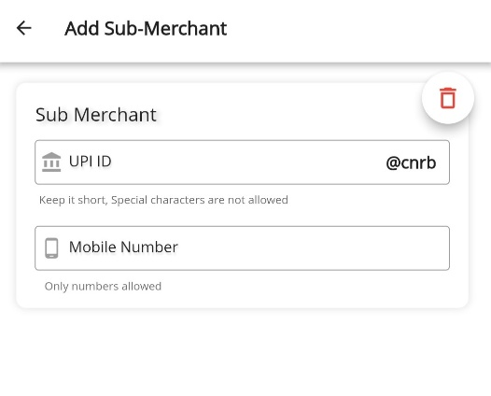
Add Sub Merchant:
Sub Merchant can be added in the App with distinct VPA ID and mobile number, to make this VPA ID activated, branch needs to approve the request in BHIM QR Merchant Portal. Sub-Merchant request can be initiated/updated in the app with distinct VPA and mobile number which is to be approved by the branch through QR SAS portal.
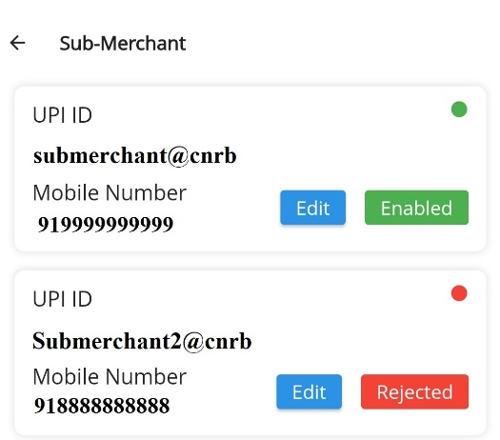
Sub Merchant’s VPA status can be seen and Mobile number can be updated in the Menu.

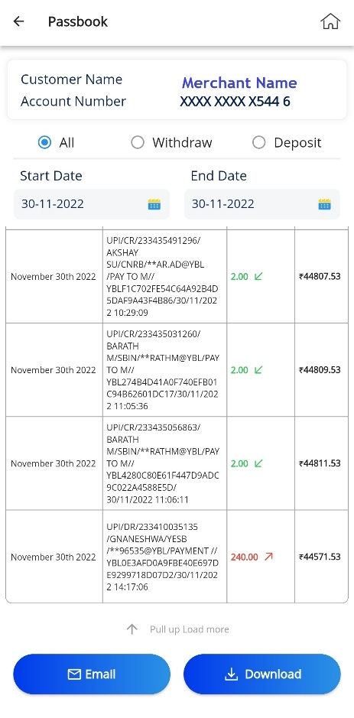
Passbook
Main Merchant has access of passbook/statement/summarized QR statement of the account in application with the option to see All, only Withdraw, only Deposit.

Option of date range selection
(up to last 6 months)

Email statement to registered mail ID

Download statement (Profile/My Files)

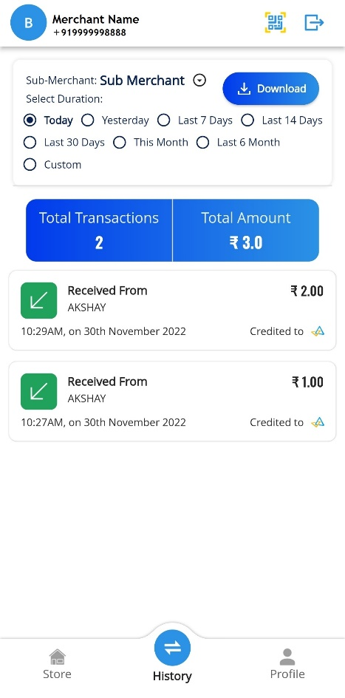
Transaction History
Sub Merchant option for main Merchant to see transactions of different linked VPAs to his account
Option to view QR transaction history VPA ID wise with date range selection (Today, Yesterday, Last 7 days etc.)
Date Range Can be selected for the Transaction History (Today, Yesterday, Last 7 days etc.)
For a selected date range, consolidated transaction count and amount received is also shown.

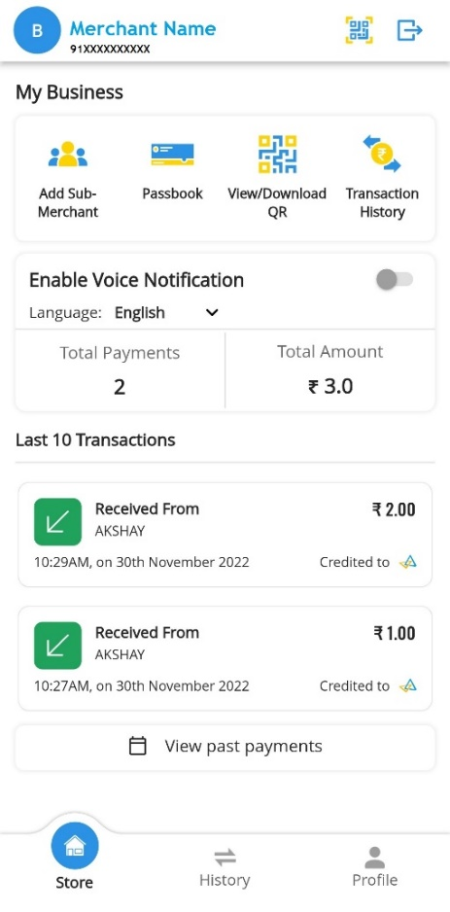
View/Download QR code:
Merchant can download the QR code to print/share to the customers.

Enable Voice Notification:
Voice notification for the successful transactions is available with 9 languages in the app.

Today’s Last 10 Transactions
For easy access to the latest transactions, up to 10 transactions of particular day are available in the home screen of the application with the consolidated total amount and count.
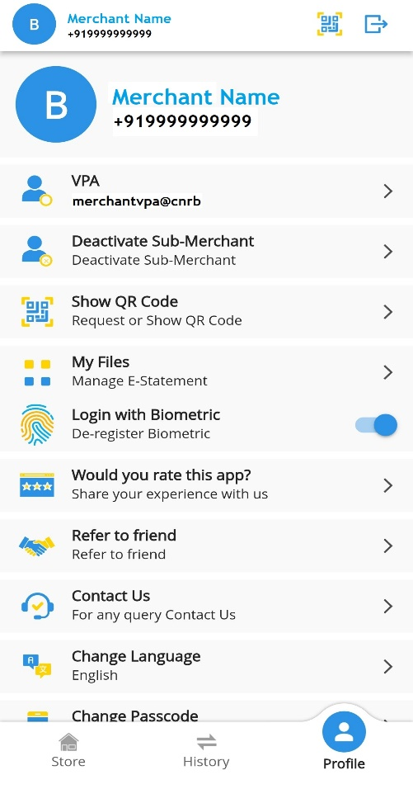
Profile
- VPA ID Information
- Deactivate Sub-Merchant
- Show QR Code
- My Files (where downloaded statement get stored)
- Login with biometric
- Refer to friend via social media platforms
like WhatsApp, Telegram etc.
- Contact Us
- Change Language:
- Application is available in 11 languages for the better user interface to Merchants in their local language.
- Change Passcode
- Terms and conditions for the Canara ai1
Merchant Application.

